**CS 322 Lab-7**

**Name**: P. V. Sriram

**Roll No.:** 1801CS37

# Store Word

**Initial Condition**: [68] = 0, $6 = 66, $3 = 0

68($3) = 68 + 0 = 68

**Instruction**: sw $6, 68($3)

**Code**: ac660044

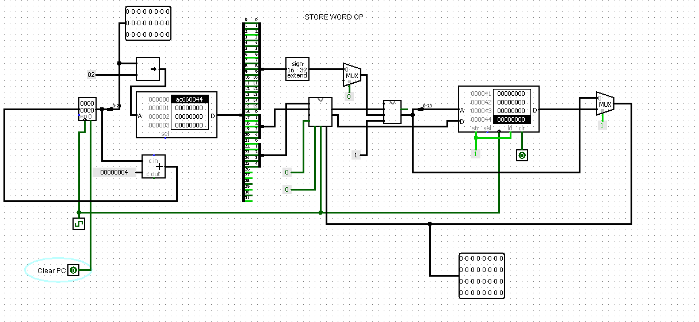

We can see that the value in address 68 is now 66

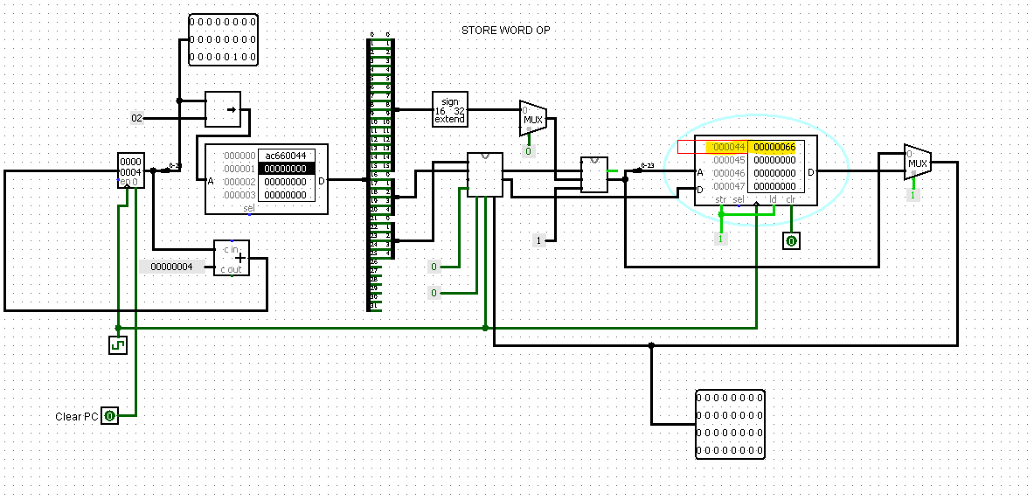

# ADD Immediate

**Initial Condition**: $2 = 0

**Instruction**:  addi, $2, $0, 5

**Code**: 20020005

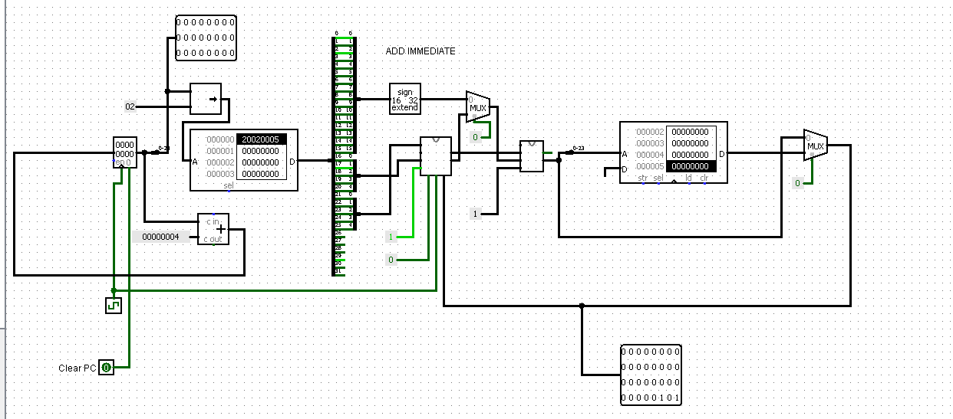

$2 = $0 + 5

$2 has been updated to 5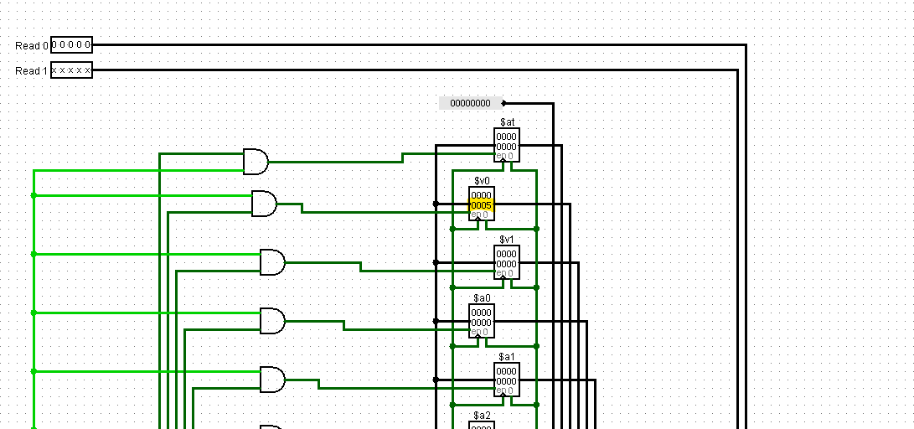

# OR Immediate

**Initial Condition**: $2 = 0

**Instruction:** ori $2, $0, 5

**Code**: 34020005

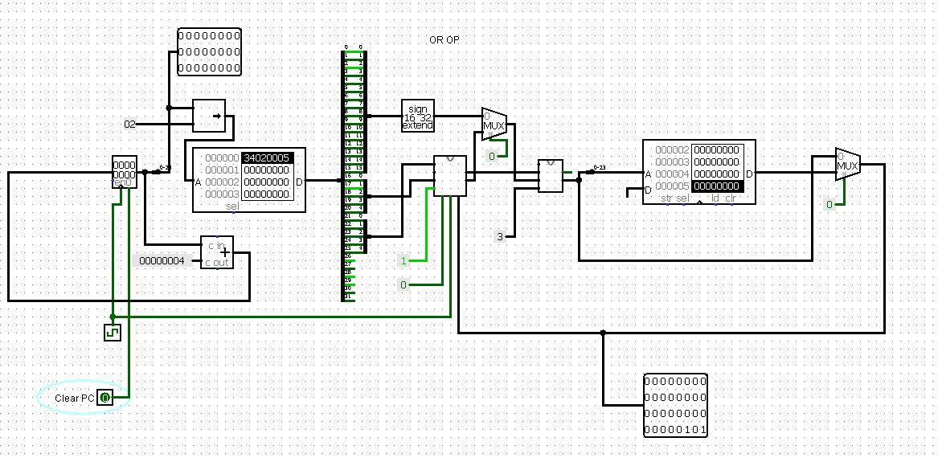

$2 = $0 or 5

$2 has been updated to 5

